Poly-XTAL operations V9.03. Free MATLAB codebase to generate and analyse complex 2D poly-crystalline grain structures

|  |  |
| --- | --- |
| Sunil Anandatheertha | Conceptualization, Software development and maintenance, documentation and manuscript preparation |
| M K Khan | Responsible for funding. Consideration of poly-crystalline grain structures in crystal plasticity-based simulations. Importance of using realistic grain structures in CPFE simulations. Supervision. |
| Michael Fitzpatrick | Responsible for funding. Preparation of manuscript. Supervision. |
| Kristina Langer | Responsible for funding. Based on her proposal to try using G-FEM framework in a meeting in 2018, the code-module and the associated data structures in Poly-XTAL Operations are so designed to incorporate finite element calculations independent of ABAQUS. |
| Suneel Motru | Inputs which have been implemented into the code **(2015-2016)**, Manuscript preparation   1. Grain boundary bridging and energy 2. Inclusion of multi-phase grain structure |
| G Narayana Naik (Masters supervisor) | Supervision **(2013-2014)**   1. Guidance in molecular mechanics based non-linear finite element analysis theory and application to graphene in MATLAB |
| N G Subramania Udupa (Masters supervisor) | Supervision **(2013-2014)** |

## Highlights

1. Free MATLAB codebase for researchers working on computational materials science, computational geology, dynamics of importance sampling Monte-Carlo schemes and graphenes.
2. Make spatiotemporally gradient 2D grain structures and associate spatiotemporally gradient crystallographic texture to the grain structure
3. Export ABAQUS input file for use in CPFEM
4. Work with Ising model and Q-state Pott’s model simulation on square lattices
5. Call MTEX libraries and mtex2gmsh routines

## Abstract

Computational materials scientists studying multi-scale thermo-mechanical and texture behaviour of poly-crystalline materials need parametric and realistically tessellated geometric morphologies of the constituent phases reflected in the virtual grain structure. They use such grain structures as an input to further studies such as crystal plasticity based finite element analysis. Though simplified and geometric grain structures have been used in the past, it is difficult to generate such parametric spatially gradient grain structures with multiple temporally low gradient slices as commonly observed in the real world. This work presents a MATLAB package which enables the users to create such grain structures and associate either experimentally observed or mathematically modelled crystallographic texture. The tool is also useful for computational geologists, mathematicians interested in different ways of energy minimized n-D space partitioning and finally statistical mechanics understanding the temporal dynamics of lattice based local and non-local discrete importance sampling Monte-Carlo systems. For material scientists, in addition to various in-built tools, ‘Poly-XTAL Operations’ can output the grain structure in a format which can be further opened in 3rd party open source libraries to tend to their specific requirements. This paper briefs the basics for using ‘Poly-XTAL Operations V9.03’ and provide examples to understand the capabilities and enable easy usage. Functionalities, capabilities and possible applications are listed. Theory, structure, format and commands are explained. Links to repository, results gallery and detailed documentation are provided.

**Keywords**: (1) Poly-XTAL Operations (2) Grain structures (3) Ising model (4) Q-State Potts model

## Background and motivation

Mathematicians, statistical mechanists and computational materials scientists are interested in studying the spatiotemporal evolutionary aspects of multi-phased partitioning of an n-dimensional space. We give four examples for this. The 1st example is from mathematics where researchers are interested in the chaotic partitioning of a n-D bounded spatial domain and its spatiotemporal evolution under some governing rules. The 2nd example is from statistical mechanics, the very well-known Ising model of the importance sampling Monte-Carlo techniques studying the spatiotemporal evolution of the kinetics and thermodynamics of the distribution of two phases in a lattice. Exact solutions have been developed for such simple models involving 2 states [1], but for more complex models like the Q-state Pott’s model, an exact model is impractical due to the vastness of the solution space. The 3rd example is from fundamental computational materials science where researchers are interested in grain growth [2], where the temporal evolution of the spatial and thermodynamical parameters of multi-phase grain structures [3,4] is studies. A part of this research also touches upon understanding the kinematic and kinetic behaviour of insoluble 2nd phase particles in grain structures [5] and how they interact with the grain boundaries. Some of these studies have tried to validate empirical models of grain structure geometry such as the Zener equation [6]. As the shape of the particles influence the Zener drag working against grain boundary evolution during grain growth [7], and that nature presents irregularly shaped particles, computer models which can consider such particle shape and their spatial distribution becomes very essential. The 4th example is from applied computational materials science where researchers need poly-crystalline grain structures to be used in techniques such as crystal plasticity based finite element analysis in order to study material’s phase-partitioned thermo-mechanical response and texture evolution under applied thermo-mechanical loads [8]. Though Voronoi tessellated geometries of grain structures have been used before in crystal plasticity-based simulations, they are simplifications and do not accurately represent the geometric irregularities presented by nature.

## Functionalities

1. Generate multi-phase 2D poly-crystalline grain structure. Ability to create:
   1. morphologically anisotropic grains
   2. spatially gradient grain morphologies in grain structure
2. Importance sampling Monte-Carlo on lattice to make realistic grains
   1. Ising model
   2. Q-state Potts model
3. Generate Voronoi equivalent of simulated and EBSD acquired grain structure
4. Consideration of following in grain growth simulation
   1. Artificial temperature gradients
   2. Spatiotemporal tracking of lattice energy
5. Grain identification and grain size statistics
6. Call MTEX libraries to:
   1. create spatial gradients in texture
   2. take advantage of its grain structure analysis routines native to MTEX
   3. carry out texture analysis
7. Export finite element mesh to ABAQUS input file for CPFEM studies using:
   1. in-built routines
   2. mtex2gmsh which uses gmsh

## Capabilities

1. Store >107 temporal slices of grain structures on a 10002 square lattice
2. Study grain boundary pinning from point particles, fully packed and sparse particle clusters (regular), thin and thick whisker reinforcements and nanotubes
3. Achieve spatial gradients in 2D Voronoi grain structure
4. Domain reduction by sparsing and sub-domain extraction
5. Open temporal slices of grain structures generated in Poly-Xtal operations in MTEX and take advantage of MTEX grain structure analysis tools
6. Track temporal evolution of grain structure statistics
7. Track temporal change in total and phase partitioned Hamiltonian
8. Generate tensile testing specimen with grain structure in the test

## Applications

1. Statistical mechanics. Study of Monte-Carlo algorithms and sampling techniques
2. FEM. Material scientists, engineers and geologists need realistic grain structures for further analysis such as crystal plasticity based finite element analysis.

## Available workflow paths

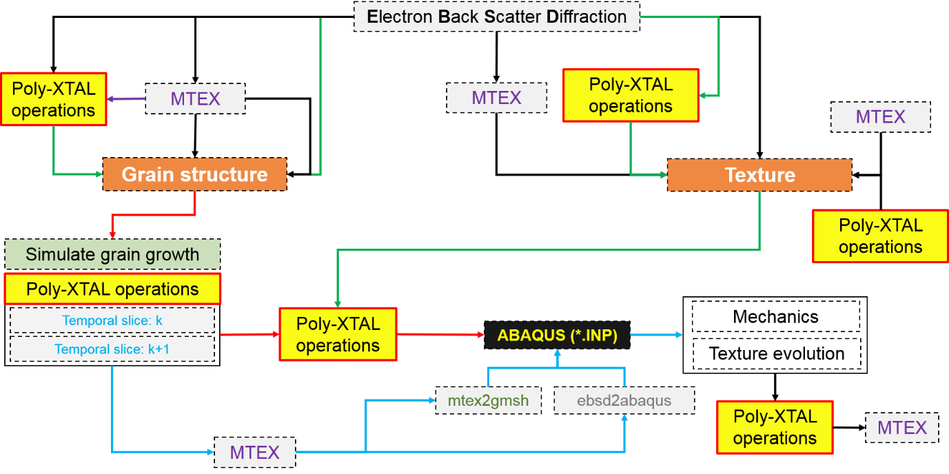

Figure 1: Some of the workflow paths which are possible

Figure 1 shows the different possibilities made available by Poly-XTAL Operations. They are detailed below.

CTF file generated using most EBSD data acquisition systems can be loaded, denoised and orientation homogenized inside MTEX. The resulting data file is exported and imported into “Poly-XTAL Operations 9.04”, where a tensile specimen can be constructed having the grain structure in the test section. Then, either a new CTF file is exported containing the tensile specimen geometry which is then imported into MTEX with the non-grain structure regions being the additional phase. This can then be exported into a compatible ABAQUS input file using either MTEX2ABAQUS() or MTEX2GMSH() routines.

As an alternative, “Poly-XTAL Operations 9.04” can directly export the tensile specimen into compatible ABAQUS input file which also includes the material property input (provided texture data is available) in the format necessitated by the ABAQUS material subroutine in FORTRAN by Huang [9]. The texture data needed can be either manually input into Poly-XTAL Operations or obtained by samplings from model textures built using MTEX in MTEX. Poly-XTAL Operations includes functionalities which can generate a depth gradient crystallographic texture such as that seen in through-thickness texture in rolled aluminium, using MTEX or directly if the prominent crystallographic orientations are known. Apart from making a virtual tensile test specimen, Poly-XTAL Operation 9.04 can also generate regular triangular and quadrilateral mesh with or without mid-side nodes for use in CPFEM in ABAQUS. An option to reduce the total number of degrees of freedom of the CPFE input is also provided, which basically produces a sparser version of the grain structure and re-exports to CPFEM ABAQUS input file.

## Some example results



Figure 11: Few example temporal slices of partitioned space having a maximum of 2 unique states.



Figure 12: Few example temporal slices of partitioned space having a maximum of 32 unique states

## References

[1] R.J. Baxter, Exactly Solved Model in Statistical Mechanics, Academic press, Harcourt Brace Jovanovich, 1989.

[2] D. Weaire, S. Mcmurry, Some Fundamentals of Grain Growth, Solid State Phys. - Adv. Res. Appl. 50 (1996) 1–36. https://doi.org/10.1016/S0081-1947(08)60603-7.

[3] M.P. Anderson, D.J. Srolovitz, G.S. Grest, P.S. Sahni, Computer simulation of grain growth-I. Kinetics, Acta Metall. 32 (1984) 783–791. https://doi.org/10.1016/0001-6160(84)90151-2.

[4] M.P. Anderson, G.S. Grest, R.D. Doherty, K. Li, D.J. Srolovitz, Inhibition of grain growth by second phase particles: Three dimensional Monte Carlo computer simulations, Scr. Metall. 23 (1989) 753–758. https://doi.org/10.1016/0036-9748(89)90525-5.

[5] D.J. Srolovitz, M.P. Anderson, G.S. Grest, P.S. Sahni, Computer simulation of grain growth-III. Influence of a particle dispersion, Acta Metall. 32 (1984) 1429–1438. https://doi.org/10.1016/0001-6160(84)90089-0.

[6] P.A. Manohar, M. Ferry, T. Chandra, Five Decades of the Zener Equation, ISIJ Int. 38 (1998) 913–924. https://doi.org/10.2355/isijinternational.38.913.

[7] W.B. Li, K.E. Easterling, The influence of particle shape on zener drag, Acta Metall. Mater. 38 (1990) 1045–1052. https://doi.org/10.1016/0956-7151(90)90177-I.

[8] F. Roters, P. Eisenlohr, L. Hantcherli, D.D. Tjahjanto, T.R. Bieler, D. Raabe, Overview of constitutive laws, kinematics, homogenization and multiscale methods in crystal plasticity finite-element modeling: Theory, experiments, applications, Acta Mater. 58 (2010) 1152–1211. https://doi.org/10.1016/j.actamat.2009.10.058.

[9] Y G Huang, A user-material subroutine incorporating single crystal plasticity in the ABAQUS finite element program, n.d.

[10] F. Bachmann, R. Hielscher, H. Schaeben, Texture analysis with MTEX- Free and open source software toolbox, Solid State Phenom. 160 (2010) 63–68. https://doi.org/10.4028/www.scientific.net/SSP.160.63.

[11] F. Bachmann, R. Hielscher, H. Schaeben, Grain detection from 2d and 3d EBSD data-Specification of the MTEX algorithm, Ultramicroscopy. 111 (2011) 1720–1733. https://doi.org/10.1016/j.ultramic.2011.08.002.